

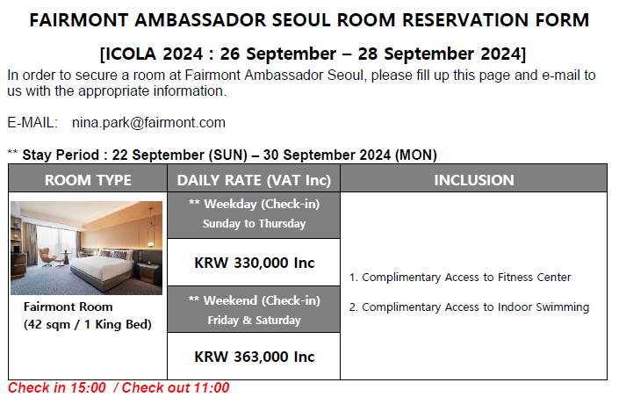

|  |  |  |  |
| --- | --- | --- | --- |
| ***GUEST INFORMATION*** | | | |
| ***First Name*** |  | ***Last Name*** |  |
| ***Nationality*** |  | ***Accor Membership*** |  |
| ***Telephone*** | + | ***E-mail*** |  |

|  |  |  |  |
| --- | --- | --- | --- |
| ***ROOM*** | | | |
| ***Check-in Date*** |  | ***Check-out Date*** |  |
| ***Room Type*** | KING ☐ | ***Number of guests*** | 1 ☐ 2 ☐ |
| ***Special Requirements*** |  | | |

|  |  |  |  |
| --- | --- | --- | --- |
| ***CREDIT CARD DETAILS*** | | | |
| ***Type*** | American Express ☐ VISA ☐ MASTER ☐ BC ☐ | | |
| ***Number*** |  | ***Valid Date*** | *MM/YY* |

**CANCELLATION POLICY**

**3 Days prior to arrival** to avoid one night cancellation penalty.

**SIGNATURE: DATE:**